Automation Test Reference

*Teamjim, 310 term project, developed by Muzhi Yang*

1. Introduction to Webload

WebLOAD is load testing tool, performance testing, and stress test web applications. This web and mobile load testing and analysis tool is from RadView Software. Load testing tool WebLOAD combines performance, scalability, and integrity as a single process for the verification of web and mobile applications. It can simulate hundreds of thousands of concurrent users making it possible to test large loads and report bottlenecks, constraints, and weak points within an application.

Using its multi-protocol support, WebLOAD simulates traffic of hundreds of thousands of users and provides analysis data on how the application behaves under load. WebLOAD monitors and incorporates statistics from the various components of the system under test: servers, application server, database, network, load-balancer, firewall, etc., and can also monitor the End User Experience and Service Level Agreement (SLA) compliance in production environments.

1. Testing Field

Our production can be roughly divided into three part: post & update all the data part, map part and admin query part. The part that is most critical and can appear many problems is the first part. Because it including the data transaction with the database. Also, for the map part we just use Google’s technology and for the admin part it is relatively simple – just query and view all the data in the mongodb. Therefore, we focus on the quality of the second part and decide to develop automation test for this part.

1. Testing principal

By using the power of the WEBLOAD IDE, I can create a/many mock object(s) and pretend to be a real customers. I created many external files which are related to several different test case, and WEBLOAD can read the external files and put these values that read from external files into our production. After finishing these step, WEBLOAD will send the request and get the result page. After transferring the page to pure html file, now I can search the html to see whether my ideal result is in it or not.

1. Test Case

* Input animal ID only
* Input animal ID with lost post
* Input animal ID with found post
* Delete animal ID only
* Delete animal ID with lost post
* Delete animal ID with found post
* Combination of all situation

1. Testing Result

* Input animal ID only:

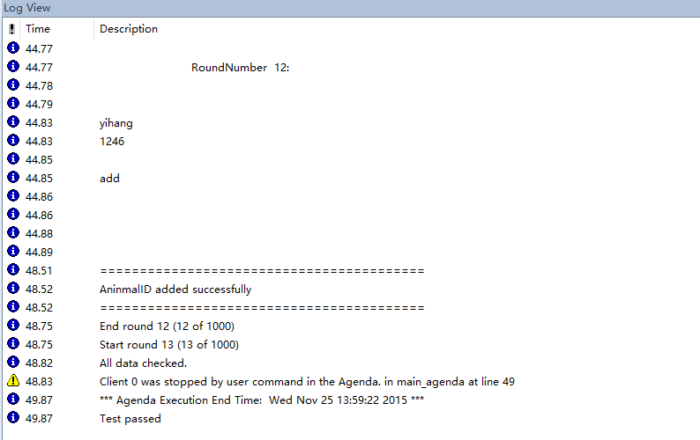

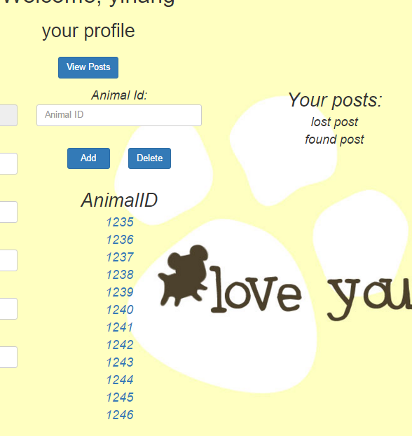

* Delete animal ID only:

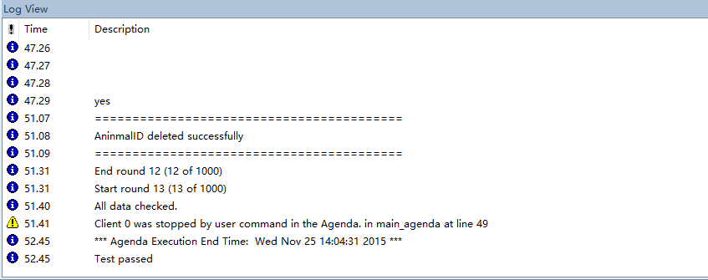

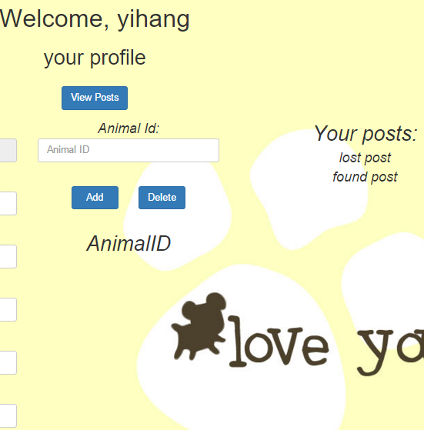

* Add Animal ID with lost post:

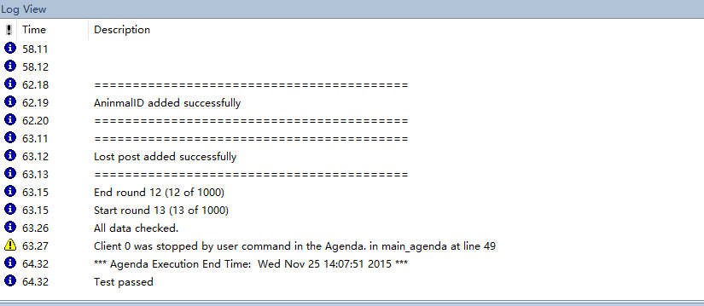

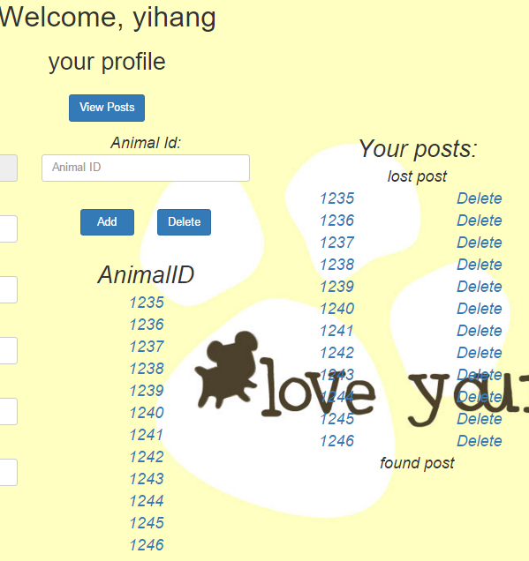

Our production passed all the test cases and the above pictures is the evidence for this. Pictures only shows partial outcomes and if you want to see the full result, just run the script which in the very end together with our production.

Attachment: Script

*function InitAgenda()*

*{*

*wlGlobals.MultiIPSupport = false*

*wlGlobals.MultiIPSupportProtocol = false*

*wlGlobals.MultiIPSupportType = "PerRound"*

*wlGlobals.SaveSource = true*

*/\* Input only AnimalID\*/*

*//InFile = CopyFile("C:\\Users\\Muzhi\\Desktop\\input1.csv")*

*/\* Delete all AnimalID\*/*

*//InFile = CopyFile("C:\\Users\\Muzhi\\Desktop\\delete1.csv")*

*/\* Input AnimalID with Lost post\*/*

*InFile = CopyFile("C:\\Users\\Muzhi\\Desktop\\input2.csv")*

*/\* Delete Lost post with AnimalID\*/*

*//InFile = CopyFile("C:\\Users\\Muzhi\\Desktop\\delete2.csv")*

*/\* Delete only Lost post\*/*

*//InFile = CopyFile("C:\\Users\\Muzhi\\Desktop\\delete3.csv")*

*/\*Input AnimalID with found post\*/*

*//InFile = CopyFile("C:\\Users\\Muzhi\\Desktop\\input3.csv")*

*/\*Delete only found post\*/*

*//InFile = CopyFile("C:\\Users\\Muzhi\\Desktop\\delete4.csv")*

*/\*Delete found post with AnimalID\*/*

*//InFile = CopyFile("C:\\Users\\Muzhi\\Desktop\\delete5.csv")*

*/\*overall test\*/*

*//InFile = CopyFile("C:\\Users\\Muzhi\\Desktop\\test.csv")*

*}*

*function InitClient()*

*{*

*wlRand.Seed(ClientNum);*

*}*

*/\*\*\*\*\* WLIDE - JavaScriptObject - ID:30 \*\*\*\*\*/*

*if(RoundNum == 1) {*

*myDataArray = GetLine(InFile,"|")*

*flag = myDataArray[0]*

*myDataArray = GetLine(InFile,"|")*

*}*

*else {*

*myDataArray = GetLine(InFile,"|")*

*}*

*if(RoundNum == 1) {*

*// Set the global array only in the first round so that it won't be rewrite after each round ends*

*p = new Array()*

*}*

*else {*

*if(myDataArray[0] == flag) {*

*InfoMessage("All data checked. ")*

*StopClient()*

*}*

*}*

*InfoMessage("======================================================================================")*

*InfoMessage(" ")*

*InfoMessage(" RoundNumber" + " " + RoundNum + ":")*

*InfoMessage(" ")*

*InfoMessage(" ")*

*myUsername = myDataArray[1]*

*myAnimalID = myDataArray[2]*

*myAddress = myDataArray[3]*

*Type = myDataArray[4]*

*myDellost = myDataArray[5]*

*addType = myDataArray[6]*

*myDelfound = myDataArray[7]*

*myDelid = myDataArray[8]*

*InfoMessage(myUsername)*

*InfoMessage(myAnimalID)*

*InfoMessage(myAddress)*

*InfoMessage(Type)*

*InfoMessage(myDellost)*

*InfoMessage(addType)*

*InfoMessage(myDelfound)*

*InfoMessage(myDelid)*

*// END WLIDE*

*/\*\*\*\*\* WLIDE - URL : http://localhost:3000/ - ID:2 \*\*\*\*\*/*

*wlGlobals.GetFrames = false*

*wlGlobals.UserAgent = "Mozilla/5.0 (Windows NT 10.0; WOW64) AppleWebKit/537.36 (KHTML, like Gecko) Chrome/46.0.2490.86 Safari/537.36"*

*wlHttp.Header["Upgrade-Insecure-Requests"] = "1"*

*wlHttp.Get("http://localhost:3000/")*

*// END WLIDE*

*/\*\*\*\*\* WLIDE - BeginTransaction::login - ID:3 \*\*\*\*\*/*

*BeginTransaction("login")*

*// END WLIDE*

*/\*\*\*\*\* WLIDE - URL : http://localhost:3000/user - ID:5 \*\*\*\*\*/*

*wlHttp.Header["Origin"] = "http://localhost:3000"*

*wlHttp.Header["X-Requested-With"] = "XMLHttpRequest"*

*wlHttp.Header["Referer"] = "http://localhost:3000/"*

*wlHttp.FormdataEncodingType = 1*

*wlHttp.ContentType = "application/x-www-form-urlencoded; charset=UTF-8"*

*wlHttp.FormData["username"] = "yihang"*

*wlHttp.FormData["password"] = "123"*

*wlHttp.Post("http://localhost:3000/user")*

*// END WLIDE*

*/\*\*\*\*\* WLIDE - URL : http://localhost:3000/user/profile - ID:6 \*\*\*\*\*/*

*wlHttp.Header["Origin"] = "http://localhost:3000"*

*wlHttp.Header["Upgrade-Insecure-Requests"] = "1"*

*wlHttp.Header["Referer"] = "http://localhost:3000/"*

*wlHttp.FormdataEncodingType = 1*

*wlHttp.ContentType = "application/x-www-form-urlencoded"*

*wlHttp.FormData["username"] = "yihang"*

*wlHttp.FormData["password"] = "123"*

*wlHttp.Post("http://localhost:3000/user/profile")*

*// END WLIDE*

*/\*\*\*\*\* WLIDE - URL : http://localhost:3000/user/getdata - ID:7 \*\*\*\*\*/*

*wlHttp.Header["Origin"] = "http://localhost:3000"*

*wlHttp.Header["X-Requested-With"] = "XMLHttpRequest"*

*wlHttp.Header["Referer"] = "http://localhost:3000/user/profile"*

*wlHttp.FormdataEncodingType = 1*

*wlHttp.ContentType = "application/x-www-form-urlencoded; charset=UTF-8"*

*wlHttp.FormData["username"] = "yihang"*

*wlHttp.Post("http://localhost:3000/user/getdata")*

*// END WLIDE*

*/\*\*\*\*\* WLIDE - URL : http://localhost:3000/posts/myLost - ID:8 \*\*\*\*\*/*

*wlHttp.Header["Origin"] = "http://localhost:3000"*

*wlHttp.Header["X-Requested-With"] = "XMLHttpRequest"*

*wlHttp.Header["Referer"] = "http://localhost:3000/user/profile"*

*wlHttp.FormdataEncodingType = 1*

*wlHttp.ContentType = "application/x-www-form-urlencoded; charset=UTF-8"*

*wlHttp.FormData["Username"] = "yihang"*

*wlHttp.Post("http://localhost:3000/posts/myLost")*

*// END WLIDE*

*/\*\*\*\*\* WLIDE - URL : http://localhost:3000/posts/myFound - ID:9 \*\*\*\*\*/*

*wlHttp.Header["Origin"] = "http://localhost:3000"*

*wlHttp.Header["X-Requested-With"] = "XMLHttpRequest"*

*wlHttp.Header["Referer"] = "http://localhost:3000/user/profile"*

*wlHttp.FormdataEncodingType = 1*

*wlHttp.ContentType = "application/x-www-form-urlencoded; charset=UTF-8"*

*wlHttp.FormData["Username"] = "yihang"*

*wlHttp.Post("http://localhost:3000/posts/myFound")*

*// END WLIDE*

*/\*\*\*\*\* WLIDE - EndTransaction::login - ID:10 \*\*\*\*\*/*

*EndTransaction("login",WLSuccess,false)*

*// END WLIDE*

*/\*\*\*\*\* WLIDE - BeginTransaction::addid - ID:11 \*\*\*\*\*/*

*BeginTransaction("addid")*

*// END WLIDE*

*/\*\*\*\*\* WLIDE - Sleep - ID:12 \*\*\*\*\*/*

*Sleep(1000)*

*// END WLIDE*

*/\*\*\*\*\* WLIDE - URL : http://localhost:3000/user/addpet - ID:13 \*\*\*\*\*/*

*if(Type == "add") {*

*wlHttp.Header["Origin"] = "http://localhost:3000"*

*wlHttp.Header["X-Requested-With"] = "XMLHttpRequest"*

*wlHttp.Header["Referer"] = "http://localhost:3000/user/profile"*

*wlHttp.FormdataEncodingType = 1*

*wlHttp.ContentType = "application/x-www-form-urlencoded; charset=UTF-8"*

*wlHttp.FormData["id"] = myAnimalID*

*wlHttp.FormData["username"] = myUsername*

*wlHttp.Post("http://localhost:3000/user/addpet")*

*}*

*if(Type == "delete") {*

*if(myDelid == "yes"){*

*wlHttp.Header["Origin"] = "http://localhost:3000"*

*wlHttp.Header["X-Requested-With"] = "XMLHttpRequest"*

*wlHttp.Header["Referer"] = "http://localhost:3000/user/profile"*

*wlHttp.FormdataEncodingType = 1*

*wlHttp.ContentType = "application/x-www-form-urlencoded; charset=UTF-8"*

*wlHttp.FormData["id"] = myAnimalID*

*wlHttp.FormData["username"] = myUsername*

*wlHttp.Post("http://localhost:3000/user/deletepet")*

*}*

*}*

*// END WLIDE*

*/\*\*\*\*\* WLIDE - Sleep - ID:14 \*\*\*\*\*/*

*Sleep(1000)*

*// END WLIDE*

*/\*\*\*\*\* WLIDE - URL : http://localhost:3000/user/getdata - ID:15 \*\*\*\*\*/*

*wlHttp.Header["Origin"] = "http://localhost:3000"*

*wlHttp.Header["X-Requested-With"] = "XMLHttpRequest"*

*wlHttp.Header["Referer"] = "http://localhost:3000/user/profile"*

*wlHttp.FormdataEncodingType = 1*

*wlHttp.ContentType = "application/x-www-form-urlencoded; charset=UTF-8"*

*wlHttp.FormData["username"] = "yihang"*

*wlHttp.Post("http://localhost:3000/user/getdata")*

*// END WLIDE*

*/\*\*\*\*\* WLIDE - JavaScriptObject - ID:31 \*\*\*\*\*/*

*verify1 = document.wlSource.search(myAnimalID)*

*if(Type == "add") {*

*if(verify1 != -1) {*

*InfoMessage("=========================================")*

*InfoMessage("AninmalID added successfully")*

*InfoMessage("=========================================")*

*}*

*else {*

*InfoMessage("=========================================")*

*InfoMessage("Adding failed")*

*InfoMessage("=========================================")*

*}*

*}*

*if(Type == "delete" && myDelid == "yes") {*

*if(verify1 == -1) {*

*InfoMessage("=========================================")*

*InfoMessage("AninmalID deleted successfully")*

*InfoMessage("=========================================")*

*}*

*else {*

*InfoMessage("=========================================")*

*InfoMessage("Adding failed")*

*InfoMessage("=========================================")*

*}*

*}*

*// END WLIDE*

*/\*\*\*\*\* WLIDE - EndTransaction::addid - ID:16 \*\*\*\*\*/*

*EndTransaction("addid",WLSuccess,false)*

*// END WLIDE*

*/\*\*\*\*\* WLIDE - BeginTransaction::addlost - ID:17 \*\*\*\*\*/*

*BeginTransaction("addlost")*

*// END WLIDE*

*/\*\*\*\*\* WLIDE - Sleep - ID:20 \*\*\*\*\*/*

*Sleep(1000)*

*// END WLIDE*

*/\*\*\*\*\* WLIDE - URL : http://localhost:3000/posts/addLost - ID:21 \*\*\*\*\*/*

*if(Type == "add") {*

*if(addType == "lost") {*

*wlHttp.Header["Origin"] = "http://localhost:3000"*

*wlHttp.Header["X-Requested-With"] = "XMLHttpRequest"*

*wlHttp.Header["Referer"] = "http://localhost:3000/user/profile"*

*wlHttp.FormdataEncodingType = 1*

*wlHttp.ContentType = "application/x-www-form-urlencoded; charset=UTF-8"*

*wlHttp.FormData["Username"] = myUsername*

*wlHttp.FormData["AnimalID"] = myAnimalID*

*wlHttp.FormData["Lat"] = "30.3779019"*

*wlHttp.FormData["Long"] = "76.7644626"*

*wlHttp.FormData["Des"] = "$WL$EMPTY$STRING$"*

*wlHttp.FormData["Address"] = myAddress*

*wlHttp.Post("http://localhost:3000/posts/addLost")*

*// END WLIDE*

*/\*\*\*\*\* WLIDE - Sleep - ID:22 \*\*\*\*\*/*

*Sleep(1000)*

*// END WLIDE*

*/\*\*\*\*\* WLIDE - URL : http://localhost:3000/posts/myLost - ID:23 \*\*\*\*\*/*

*wlHttp.Header["Origin"] = "http://localhost:3000"*

*wlHttp.Header["X-Requested-With"] = "XMLHttpRequest"*

*wlHttp.Header["Referer"] = "http://localhost:3000/user/profile"*

*wlHttp.FormdataEncodingType = 1*

*wlHttp.ContentType = "application/x-www-form-urlencoded; charset=UTF-8"*

*wlHttp.FormData["Username"] = myUsername*

*wlHttp.Post("http://localhost:3000/posts/myLost")*

*// END WLIDE*

*/\*\*\*\*\* WLIDE - URL : http://localhost:3000/posts/myFound - ID:24 \*\*\*\*\*/*

*wlHttp.Header["Origin"] = "http://localhost:3000"*

*wlHttp.Header["X-Requested-With"] = "XMLHttpRequest"*

*wlHttp.Header["Referer"] = "http://localhost:3000/user/profile"*

*wlHttp.FormdataEncodingType = 1*

*wlHttp.ContentType = "application/x-www-form-urlencoded; charset=UTF-8"*

*wlHttp.FormData["Username"] = myUsername*

*wlHttp.Post("http://localhost:3000/posts/myFound")*

*}*

*if(addType == "found"){*

*wlHttp.Header["Origin"] = "http://localhost:3000"*

*wlHttp.Header["X-Requested-With"] = "XMLHttpRequest"*

*wlHttp.Header["Referer"] = "http://localhost:3000/user/profile"*

*wlHttp.FormdataEncodingType = 1*

*wlHttp.ContentType = "application/x-www-form-urlencoded; charset=UTF-8"*

*wlHttp.FormData["Username"] = myUsername*

*wlHttp.FormData["AnimalID"] = myAnimalID*

*wlHttp.FormData["Lat"] = "35.5998769"*

*wlHttp.FormData["Long"] = "139.5352586"*

*wlHttp.FormData["Phone"] = "11111"*

*wlHttp.FormData["Des"] = "11111"*

*wlHttp.FormData["Address"] = myAddress*

*wlHttp.Post("http://localhost:3000/posts/addFound")*

*wlHttp.Header["Origin"] = "http://localhost:3000"*

*wlHttp.Header["X-Requested-With"] = "XMLHttpRequest"*

*wlHttp.Header["Referer"] = "http://localhost:3000/user/profile"*

*wlHttp.FormdataEncodingType = 1*

*wlHttp.ContentType = "application/x-www-form-urlencoded; charset=UTF-8"*

*wlHttp.FormData["Username"] = myUsername*

*wlHttp.Post("http://localhost:3000/posts/myLost")*

*wlHttp.Header["Origin"] = "http://localhost:3000"*

*wlHttp.Header["X-Requested-With"] = "XMLHttpRequest"*

*wlHttp.Header["Referer"] = "http://localhost:3000/user/profile"*

*wlHttp.FormdataEncodingType = 1*

*wlHttp.ContentType = "application/x-www-form-urlencoded; charset=UTF-8"*

*wlHttp.FormData["Username"] = myUsername*

*wlHttp.Post("http://localhost:3000/posts/myFound")*

*}*

*}*

*// END WLIDE*

*/\*\*\*\*\* WLIDE - JavaScriptObject - ID:33 \*\*\*\*\*/*

*if(Type == "delete") {*

*if(myDellost == "yes") {*

*wlHttp.Header["Origin"] = "http://localhost:3000"*

*wlHttp.Header["X-Requested-With"] = "XMLHttpRequest"*

*wlHttp.Header["Referer"] = "http://localhost:3000/user/profile"*

*wlHttp.FormdataEncodingType = 1*

*wlHttp.ContentType = "application/x-www-form-urlencoded; charset=UTF-8"*

*wlHttp.FormData["petid"] = myAnimalID*

*wlHttp.FormData["collection"] = "Lost"*

*wlHttp.FormData["username"] = myUsername*

*wlHttp.Post("http://localhost:3000/posts/delete")*

*wlHttp.Header["Origin"] = "http://localhost:3000"*

*wlHttp.Header["X-Requested-With"] = "XMLHttpRequest"*

*wlHttp.Header["Referer"] = "http://localhost:3000/user/profile"*

*wlHttp.FormdataEncodingType = 1*

*wlHttp.ContentType = "application/x-www-form-urlencoded; charset=UTF-8"*

*wlHttp.FormData["Username"] = myUsername*

*wlHttp.Post("http://localhost:3000/posts/myLost")*

*wlHttp.Header["Origin"] = "http://localhost:3000"*

*wlHttp.Header["X-Requested-With"] = "XMLHttpRequest"*

*wlHttp.Header["Referer"] = "http://localhost:3000/user/profile"*

*wlHttp.FormdataEncodingType = 1*

*wlHttp.ContentType = "application/x-www-form-urlencoded; charset=UTF-8"*

*wlHttp.FormData["Username"] = myUsername*

*wlHttp.Post("http://localhost:3000/posts/myFound")*

*}*

*else if(myDelfound == "yes"){*

*wlHttp.Header["Origin"] = "http://localhost:3000"*

*wlHttp.Header["X-Requested-With"] = "XMLHttpRequest"*

*wlHttp.Header["Referer"] = "http://localhost:3000/user/profile"*

*wlHttp.FormdataEncodingType = 1*

*wlHttp.ContentType = "application/x-www-form-urlencoded; charset=UTF-8"*

*wlHttp.FormData["petid"] = myAnimalID*

*wlHttp.FormData["collection"] = "Found"*

*wlHttp.FormData["username"] = myUsername*

*wlHttp.Post("http://localhost:3000/posts/delete")*

*wlHttp.Header["Origin"] = "http://localhost:3000"*

*wlHttp.Header["X-Requested-With"] = "XMLHttpRequest"*

*wlHttp.Header["Referer"] = "http://localhost:3000/user/profile"*

*wlHttp.FormdataEncodingType = 1*

*wlHttp.ContentType = "application/x-www-form-urlencoded; charset=UTF-8"*

*wlHttp.FormData["Username"] = myUsername*

*wlHttp.Post("http://localhost:3000/posts/myLost")*

*wlHttp.Header["Origin"] = "http://localhost:3000"*

*wlHttp.Header["X-Requested-With"] = "XMLHttpRequest"*

*wlHttp.Header["Referer"] = "http://localhost:3000/user/profile"*

*wlHttp.FormdataEncodingType = 1*

*wlHttp.ContentType = "application/x-www-form-urlencoded; charset=UTF-8"*

*wlHttp.FormData["Username"] = myUsername*

*wlHttp.Post("http://localhost:3000/posts/myFound")*

*}*

*}*

*// END WLIDE*

*/\*\*\*\*\* WLIDE - EndTransaction::addlost - ID:25 \*\*\*\*\*/*

*EndTransaction("addlost",WLSuccess,false)*

*// END WLIDE*

*/\*\*\*\*\* WLIDE - JavaScriptObject - ID:34 \*\*\*\*\*/*

*if(Type == "delete" && (myDellost == "yes" || myDelfound == "yes")) {*

*verify3 = document.wlSource.search(myAnimalID)*

*if(verify3 == -1) {*

*InfoMessage("=========================================")*

*InfoMessage("Post deleted successfully")*

*InfoMessage("=========================================")*

*}*

*else {*

*InfoMessage("=========================================")*

*InfoMessage("Post delete fail")*

*InfoMessage("=========================================")*

*}*

*}*

*if(Type== "delete" && (myDellost == "no" || myDelfound == "no")){*

*InfoMessage("=========================================")*

*InfoMessage("No need to delete post, verify done.")*

*InfoMessage("=========================================")*

*}*

*if(Type == "add") {*

*if(addType == "lost"){*

*wlHttp.Header["X-Requested-With"] = "XMLHttpRequest"*

*wlHttp.Header["Referer"] = "http://localhost:3000/user/profile"*

*wlHttp.FormdataEncodingType = 1*

*wlHttp.FormData["petid"] = myAnimalID*

*wlHttp.FormData["collection"] = "Lost"*

*wlHttp.FormData["username"] = myUsername*

*wlHttp.Get("http://localhost:3000/posts/retrieve")*

*}*

*if(addType == "found"){*

*wlHttp.Header["X-Requested-With"] = "XMLHttpRequest"*

*wlHttp.Header["Referer"] = "http://localhost:3000/user/profile"*

*wlHttp.FormdataEncodingType = 1*

*wlHttp.FormData["petid"] = myAnimalID*

*wlHttp.FormData["collection"] = "Found"*

*wlHttp.FormData["username"] = myUsername*

*wlHttp.Get("http://localhost:3000/posts/retrieve")*

*}*

*verify2 = document.wlSource.search(myAddress)*

*if(addType == "lost") {*

*if(verify2 != -1) {*

*InfoMessage("=========================================")*

*InfoMessage("Lost post added successfully")*

*InfoMessage("=========================================")*

*}*

*else {*

*InfoMessage("=========================================")*

*InfoMessage("Failed")*

*InfoMessage("=========================================")*

*}*

*}*

*else if(addType == "found") {*

*if(verify2 != -1) {*

*InfoMessage("=========================================")*

*InfoMessage("Found post added successfully")*

*InfoMessage("=========================================")*

*}*

*else {*

*InfoMessage("=========================================")*

*InfoMessage("Failed")*

*InfoMessage("=========================================")*

*}*

*}*

*}*